EXPERIMENT 1 – MICROWAVE ENGINEERING
- TE10 Mode Simulation: A WR-90 rectangular waveguide has a = 22.86 mm, b = 10.16 mm and length L = 100 mm. Operate it at f = 10 GHz and excite the dominant TE10 mode in MATLAB. Obtain the E-field and H-field distributions, simulated cutoff frequency fc and propagation constant β. Calculate fc (theory) = c/(2a), β = (2πf/c)√[1−(fc/f)²], and the percentage deviation of simulated fc from theoretical fc.

AIM – To simulate the dominant TE₁₀ mode in a WR-90 rectangular waveguide using HFSS at 10 GHz, obtain the electric and magnetic field distributions, determine the cutoff frequency and propagation constant, and calculate the percentage deviation between simulated and theoretical cutoff frequencies.
SOFTWARE REQUIRED –
- MATLAB
PROGRAM –
clc;
clear;
close all;
% WR-90 Rectangular Waveguide Parameters
a = 22.86e-3; % Width in metres
b = 10.16e-3; % Height in metres
L = 100e-3; % Length in metres
f = 10e9; % Operating frequency = 10 GHz
c = 3e8; % Speed of light (m/s)
% Theoretical Cutoff Frequency for TE10
fc_theory = c/(2*a);
% Propagation Constant
if f > fc_theory
beta = (2*pi*f/c)*sqrt(1-(fc_theory/f)^2);
else
beta = 0;
end
% Display Results
fprintf('TE10 MODE RESULTS\n');
fprintf('-----------------------------\n');
fprintf('Theoretical cutoff frequency = %.4f GHz\n', ...
fc_theory/1e9);
fprintf('Operating frequency = %.4f GHz\n', f/1e9);
fprintf('Propagation constant beta = %.4f rad/m\n', beta);
fprintf('Guide wavelength = %.4f mm\n', 2*pi/beta*1000);
% Field Distribution Coordinates
x = linspace(0,a,100);
z = linspace(0,L,150);
[X,Z] = meshgrid(x,z);
% TE10 Electric Field: Ey variation across width
Ey = sin(pi*X/a).*cos(beta*Z);
% TE10 Magnetic Field: Hx and Hz components
Hx = -(beta/(2*pi*f*4*pi*1e-7)) .* Ey;
Hz = cos(pi*X/a).*sin(beta*Z);
% E-Field Distribution
figure;
surf(X*1000,Z*1000,Ey,'EdgeColor','none');
xlabel('Width x (mm)');
ylabel('Length z (mm)');
zlabel('Normalized Ey');
title('TE10 Electric Field Distribution');
colorbar;
view(45,30);
axis tight;
% H-Field Distribution
figure;
surf(X*1000,Z*1000,Hx,'EdgeColor','none');
xlabel('Width x (mm)');
ylabel('Length z (mm)');
zlabel('Normalized Hx');
title('TE10 Magnetic Field Distribution (Hx)');
colorbar;
view(45,30);
axis tight;
% Additional Hz Field
figure;
surf(X*1000,Z*1000,Hz,'EdgeColor','none');
xlabel('Width x (mm)');
ylabel('Length z (mm)');
zlabel('Normalized Hz');
title('TE10 Magnetic Field Distribution (Hz)');
colorbar;
view(45,30);
axis tight;

OUTPUT-
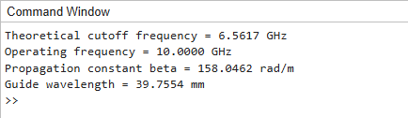
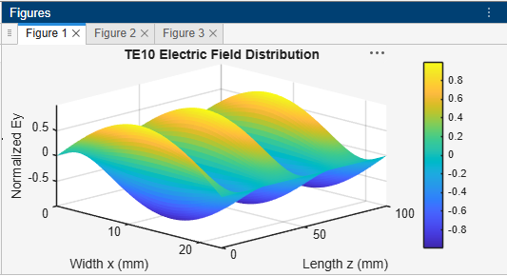
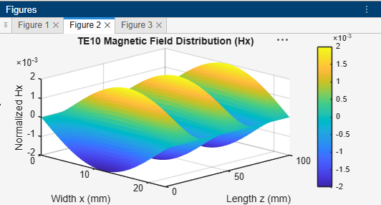
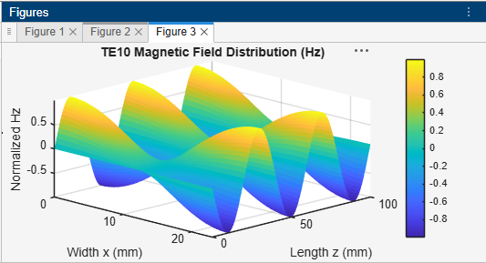

RESULT –
The TE₁₀ mode of the WR-90 rectangular waveguide was studied at 10 GHz. The theoretical cutoff frequency was calculated as approximately 6.562 GHz, and the propagation constant was found to be approximately 158.2 rad/m. Since the operating frequency is greater than the cutoff frequency, the TE₁₀ mode propagates through the waveguide. The electric and magnetic field distributions were obtained, and the percentage deviation was determined by comparing the HFSS-simulated cutoff frequency with the theoretical value.

- TE10 versus TM11: Using the same WR-90 waveguide at f = 10 GHz, simulates both TE10 and TM11 modes. Determine fc, β and the E/H-field distributions for each mode. Calculate the theoretical cutoff frequencies using fc(mn)=c/2√[(m/a)²+(n/b)²]. Compare the results and justify why TE10 propagates at 10 GHz while TM11 does not.
Aim: To simulate and compare the TE₁₀ and TM₁₁ modes in a WR-90 rectangular waveguide at 10 GHz using HFSS, determine their cutoff frequencies and propagation constants, obtain their electric and magnetic field distributions, and verify their propagation characteristics.
PROGRAM –
clc;
clear;
close all;

% WR-90 Waveguide Parameters
a = 22.86e-3; % Width (m)
b = 10.16e-3; % Height (m)
L = 100e-3; % Length (m)
f = 10e9; % Operating frequency (Hz)
c = 3e8; % Speed of light (m/s)

% Mode indices
m1 = 1; n1 = 0; % TE10
m2 = 1; n2 = 1; % TM11

% Wave number
k = 2*pi*f/c;

% Cutoff frequencies
fc_TE10 = (c/2)*sqrt((m1/a)^2 + (n1/b)^2);
fc_TM11 = (c/2)*sqrt((m2/a)^2 + (n2/b)^2);

% Cutoff wave numbers
kc_TE10 = pi*sqrt((m1/a)^2 + (n1/b)^2);
kc_TM11 = pi*sqrt((m2/a)^2 + (n2/b)^2);

% Propagation constants
beta_TE10 = sqrt(complex(k^2-kc_TE10^2));
beta_TM11 = sqrt(complex(k^2-kc_TM11^2));

% Results
fprintf('TE10 vs TM11 MODE COMPARISON\n');
fprintf('-----------------------------------\n');

fprintf('TE10 cutoff frequency = %.4f GHz\n', ...
fc_TE10/1e9);
fprintf('TE10 beta = %.4f + j(%.4f) rad/m\n', ...
real(beta_TE10), imag(beta_TE10));

fprintf('\nTM11 cutoff frequency = %.4f GHz\n', ...
fc_TM11/1e9);
fprintf('TM11 beta = %.4f + j(%.4f) rad/m\n', ...
real(beta_TM11), imag(beta_TM11));

fprintf('\nOperating frequency = %.2f GHz\n', f/1e9);

if f > fc_TE10
fprintf('TE10: PROPAGATING MODE\n');
else
fprintf('TE10: BELOW CUTOFF\n');
end

if f > fc_TM11
fprintf('TM11: PROPAGATING MODE\n');
else
fprintf('TM11: BELOW CUTOFF (EVANESCENT)\n');
end

% Cross-sectional coordinates
x = linspace(0,a,100);
y = linspace(0,b,60);
[X,Y] = meshgrid(x,y);

% TE10 normalized field patterns
Ey_TE10 = sin(pi*X/a);
Hx_TE10 = Ey_TE10;

% TM11 normalized longitudinal electric field
Ez_TM11 = sin(pi*X/a).*sin(pi*Y/b);

% TM11 normalized transverse electric-field components
Ex_TM11 = -(pi/a)*cos(pi*X/a).*sin(pi*Y/b);
Ey_TM11 = -(pi/b)*sin(pi*X/a).*cos(pi*Y/b);

% TE10 E-field
figure;
surf(X*1000,Y*1000,Ey_TE10,'EdgeColor','none');
xlabel('x (mm)');
ylabel('y (mm)');
zlabel('Normalized Ey');
title('TE10 Electric Field Distribution');
colorbar;
view(45,30);

% TE10 H-field
figure;
surf(X*1000,Y*1000,Hx_TE10,'EdgeColor','none');
xlabel('x (mm)');
ylabel('y (mm)');
zlabel('Normalized Hx');
title('TE10 Magnetic Field Pattern (Hx)');
colorbar;
view(45,30);

% TM11 longitudinal E-field
figure;
surf(X*1000,Y*1000,Ez_TM11,'EdgeColor','none');
xlabel('x (mm)');
ylabel('y (mm)');
zlabel('Normalized Ez');
title('TM11 Longitudinal Electric Field Pattern');
colorbar;
view(45,30);

% TM11 transverse E-field components
figure;
subplot(1,2,1);
surf(X*1000,Y*1000,Ex_TM11,'EdgeColor','none');
xlabel('x (mm)');
ylabel('y (mm)');
zlabel('Normalized Ex');
title('TM11 Ex Pattern');
colorbar;
view(45,30);

subplot(1,2,2);
surf(X*1000,Y*1000,Ey_TM11,'EdgeColor','none');
xlabel('x (mm)');
ylabel('y (mm)');
zlabel('Normalized Ey');
title('TM11 Ey Pattern');
colorbar;
view(45,30);

% TM11 magnetic-field pattern
% Normalized transverse magnetic components
Hx_TM11 = -(pi/b)*sin(pi*X/a).*cos(pi*Y/b);
Hy_TM11 = (pi/a)*cos(pi*X/a).*sin(pi*Y/b);

figure;
subplot(1,2,1);
surf(X*1000,Y*1000,Hx_TM11,'EdgeColor','none');
xlabel('x (mm)');
ylabel('y (mm)');
zlabel('Normalized Hx');
title('TM11 Hx Pattern');
colorbar;
view(45,30);

subplot(1,2,2);
surf(X*1000,Y*1000,Hy_TM11,'EdgeColor','none');
xlabel('x (mm)');
ylabel('y (mm)');
zlabel('Normalized Hy');
title('TM11 Hy Pattern');
colorbar;
view(45,30);
OUTPUT-
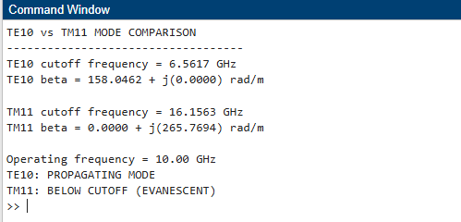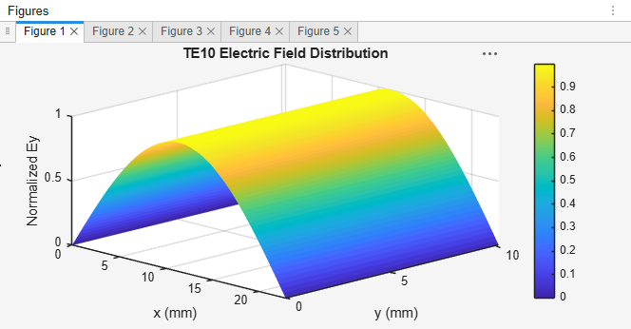
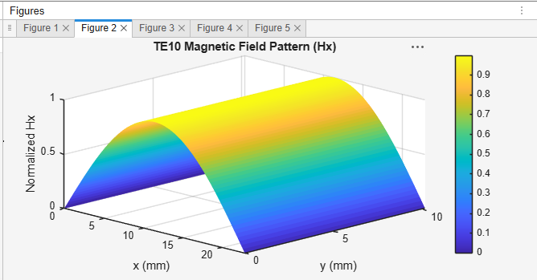
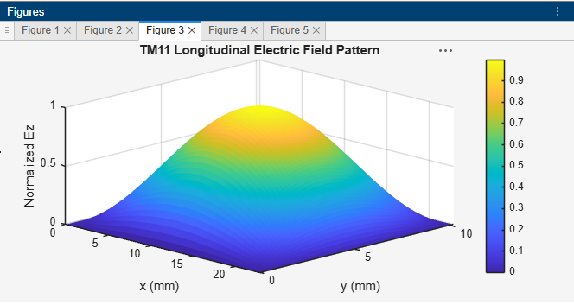
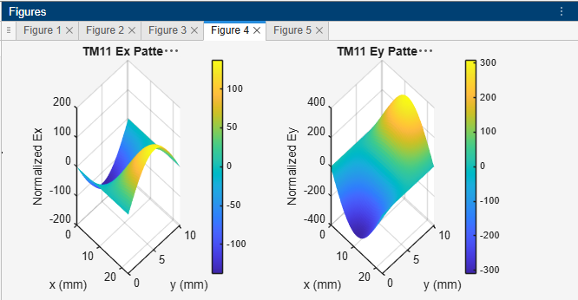
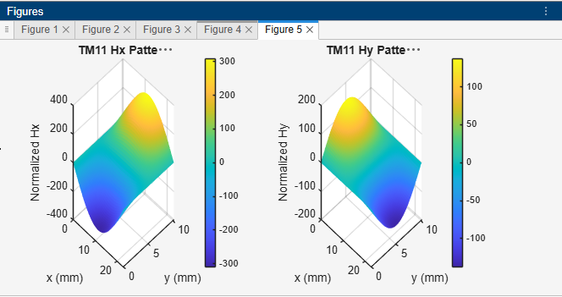
RESULT - The TE₁₀ and TM₁₁ modes were analyzed for the WR-90 rectangular waveguide at 10 GHz. The theoretical cutoff frequencies were found to be approximately 6.562 GHz for TE₁₀ and 16.15 GHz for TM₁₁. The TE₁₀ mode propagates because its cutoff frequency is below the operating frequency, whereas the TM₁₁ mode is below cutoff and exhibits evanescent behavior. The electric and magnetic field distributions were studied, confirming the different propagation characteristics of the two modes.

